**QWS3270 Secure v4.85 manual install instructions**

**Part I. Backup your customized user profile data for import to v4.85 later**

1. Right click on the QWSBackup.bat file and select “Run as administrator”.

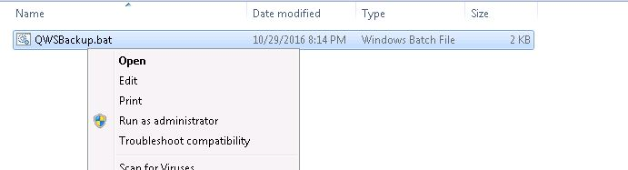

1. You should see a new folder created on the C: drive called “QWSBACKUP”. This folder contains a backup of the QWS customizations contained in your current install. If this folder is not created, please DO NOT proceed to Part II and contact Krystina Casolino, [k.casolino@columbia.edu](mailto:k.casolino@columbia.edu), 212-853-0719, for assistance.

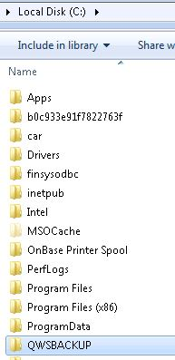

**Part II. Install the QWS3270 Secure v4.85 software package**

1. Right click on the QWS3270.EXE file and select “Run as administrator”.

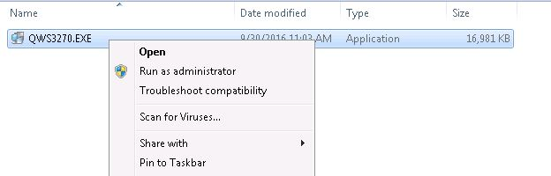

1. Click OK to complete the install.

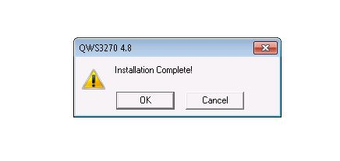

1. A shortcut for “QWS3270 Secure” will be created on the desktop.

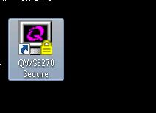

1. The installation is complete.