**Athena Desk (Advance)**

**Installation Instructions**

**For Windows 7**



**Author:** Seth Rosenberg, Training and User Services Specialist

**Office:** Office of Alumni and Development, Database and Web Initiatives

**Date Written:** May 19th, 2011

**Last Revised:** March 6th, 2014

This document is intended to guide users through the installation process for Athena Desk (formerly known as Advance) on a PC operating Windows 7. Because the version of Advance Columbia licenses (version 9.1) is not supported by SunGard, this process was created by the Database and Web Initiatives team with help from the Department of Computer Science.

The steps should be followed in the order outlined as follows.

Approximate time to complete: 10 minutes.

**Please note:** You must have administrator rights on the given PC to complete the Athena Desk installation process. If you are not a system administrator, or are not sure if you have administrator rights, please contact your IT support.

1. From the installation CD or flash drive, drag the entire folder “oracle” into the PC’s Local Disk (C:) drive.

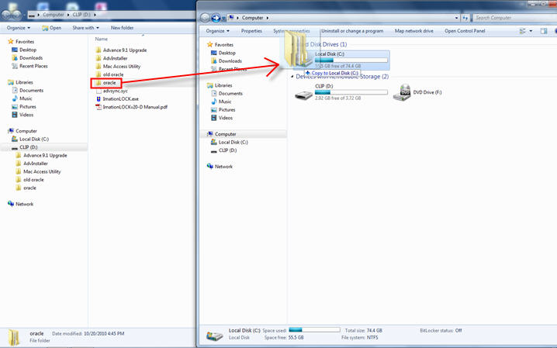

1. Go into Control Panel 🡪 System 🡪 Advanced System Settings 🡪 Environment Variables. Add a new “System variable” (the bottom of 2 lists) with the following attributes:

* Variable name: TNS_ADMIN
* Variable value: C:\oracle\admin

**\*\*Note**: The variable name is case sensitive. Also, make sure to use back-slashes, **not** forward slashes. This could cause an error later when opening Athena Desk.

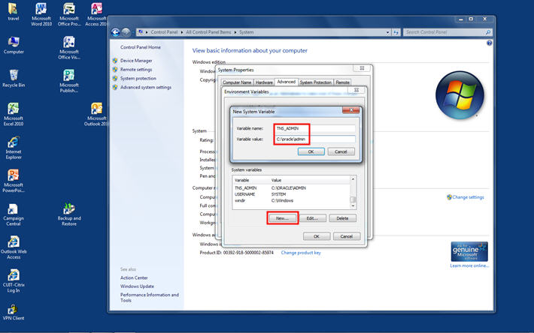

1. In the list of System Variables, find the variable named “Path.” Click Edit and go to the very end of the variable value. At the end, following a semicolon (;) add the following:

* C:\oracle\instantclient

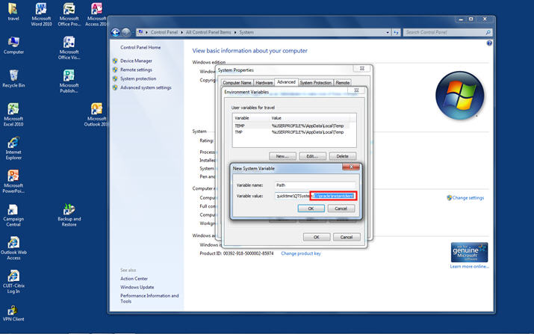

1. Go into Control Panel 🡪 Network and Sharing Center 🡪 Change Adapter Settings.
   1. Find your Local Area Network and right-click on it.
   2. Click Properties.
   3. Right click on “Internet Protocol Version 4 (TCP/IPv4)”
   4. In the General tab, click “Advanced…”
   5. In the WINS tab, click “Enable NetBIOS over TCP/IP”

**\*\*Note**: If the PC is a laptop and the user intends to use Athena Desk remotely, repeat this step for their Wireless Network Connection. They will need to connect to Columbia’s VPN before attempting to access Athena Desk.

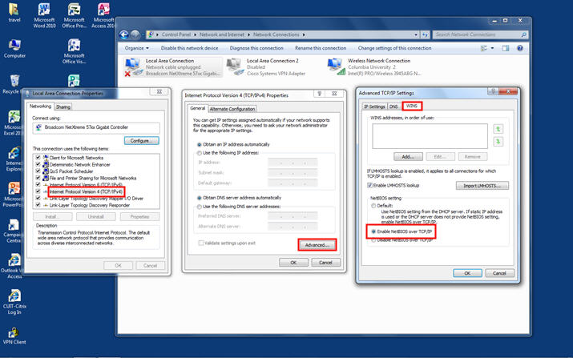

1. Back on the installation CD or flash drive, go into the folder “AdvInstaller” and open the program “AdvInstaller.msi”. Follow the instructions to install Advance (Athena Desk).

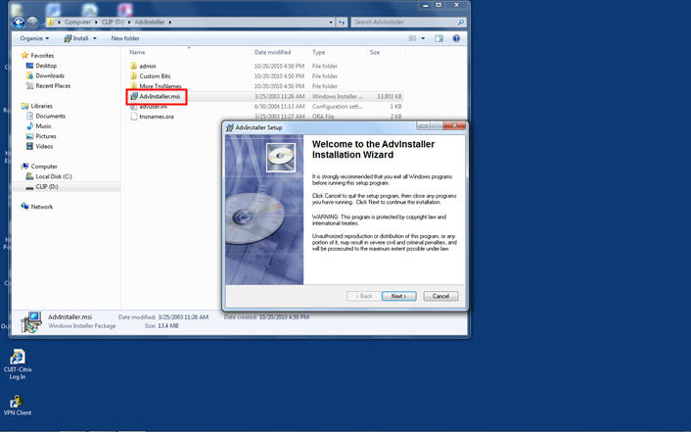

1. When prompted, make sure to click “Anyone who uses this computer”.

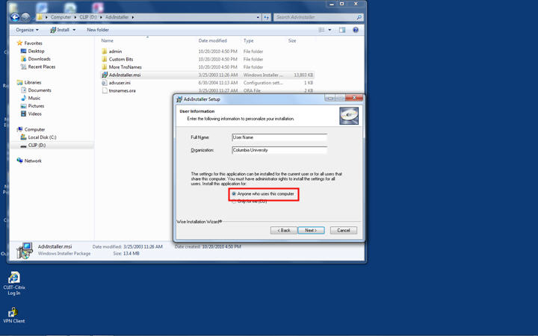

1. Once Advance (Athena Desk) has been installed, but **before** opening the program, go into Computer 🡪 Local Disk (C:) 🡪 Program Files 🡪 Advance and find the file “sync.exe”.
   1. Right click on sync.exe
   2. Click on Properties.
   3. On the Compatibility tab, click “Run this program in compatibility mode for:”.
   4. Select “Windows XP (Service Pack 3)” from the dropdown menu.

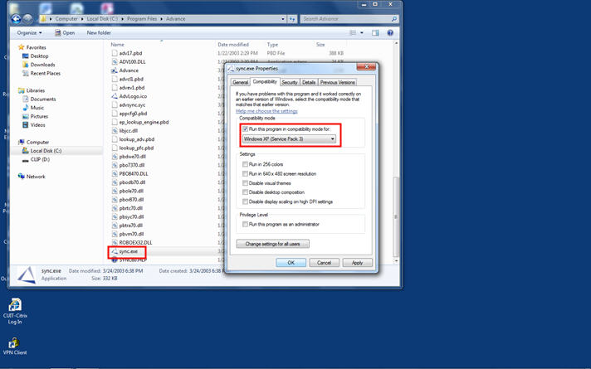

1. From the installation CD, find the file “advsync.syc” and drag it into the folder Computer 🡪 Local Disk (C:) 🡪 Program Files 🡪 Advance.

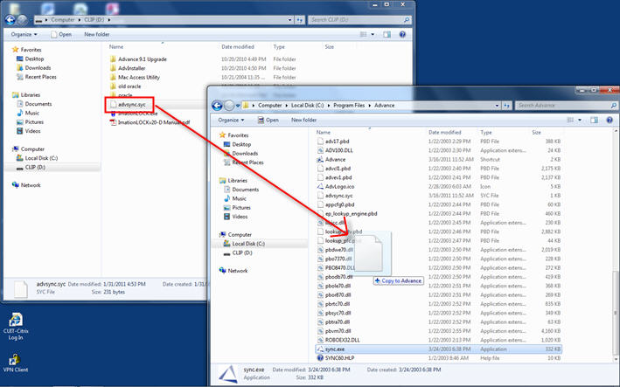

1. Make sure to click “Copy and Replace” to replace the old file.

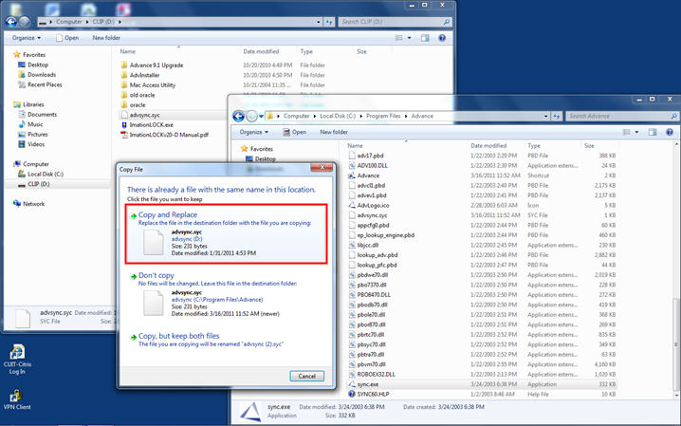

1. Now you can open Advance (Athena Desk) by double-clicking the icon on the desktop. Make sure to let the sync process run all the way through.

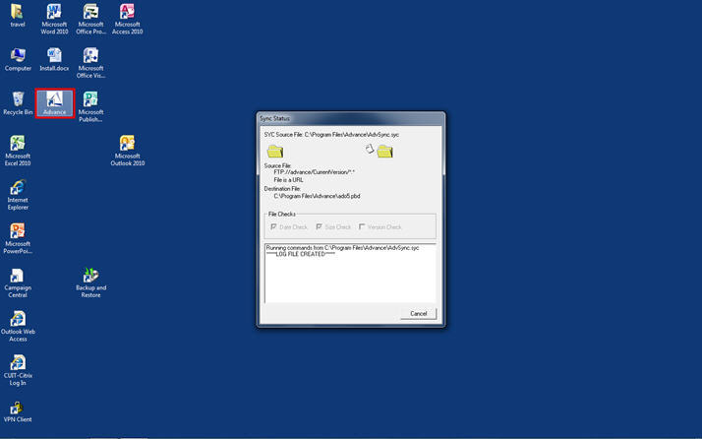

1. Once the sync process has finished, the login window will appear. Make sure the version is 9.1.

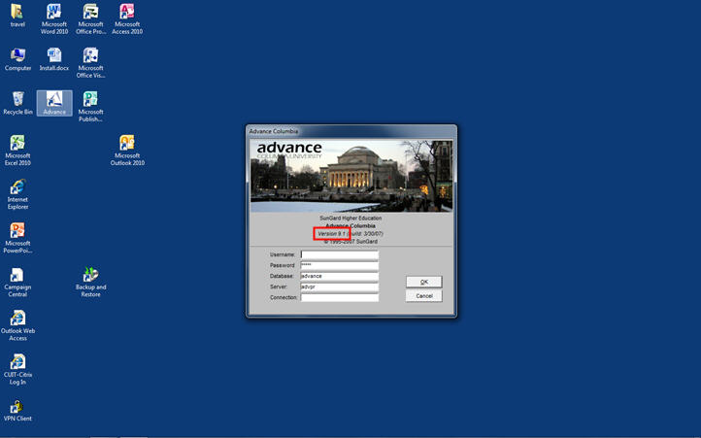

**Trouble Shoot**

**Failure to sync**

If the FTP (sync) fails after all the installation steps have been completed its most likely the firewall. Usually happens in installations outside of Development offices. You will need to disable the firewall through the users IT department:

1. Go to Windows Firewall 🡪 Advance Settings 🡪 Inbound Rules and make sure that the Advance Executable’s protocol is TCP not anything else like UDP.



Error on MAC Parallels

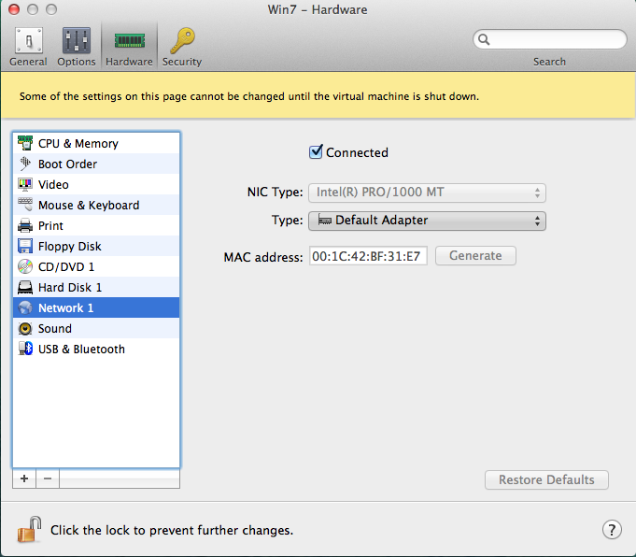

**How to fix a Runtime Error**

**To fix this problem on a Desktop, please follow these steps:**

This is symptomatic of not having network access.  (At this point, the sync utility is trying to contact the ftp server, but cannot).

Are you able to open a web browser and get to external, non-Columbia websites?

Also, please be sure to disable your laptops WiFi if you are connected via an Ethernet cable and try again.

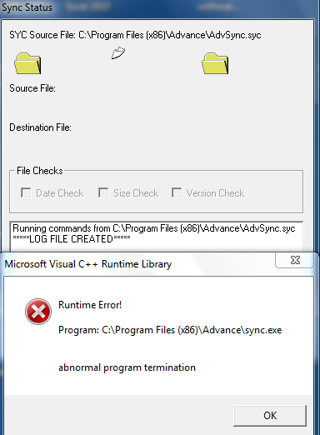

**To fix this problem on a Laptop, please follow these steps:**

If you are on a laptop when you are in you docking station, please make sure the Wireless switch is in the off position. Advance fails to run on a laptop if you are on the docking station and you have the wireless switch on. Please let me know if this helps.

**Installation Error Messages**

---------------------------

Logon to advance

---------------------------

Your credentials failed the Authentication process.

Reason: 12154: ORA-12154: TNS:could not resolve the connect identifier specified

---------------------------

OK

---------------------------

1. Add the environment variables (steps 2-3/pages 3-4 of the install instructions).

Your credentials failed the Authentication process. Reason: 999: The Oracle library OCI.DLL could not be loaded.

1. Reinstall Athena Desk

# Windows Parallel

On windows

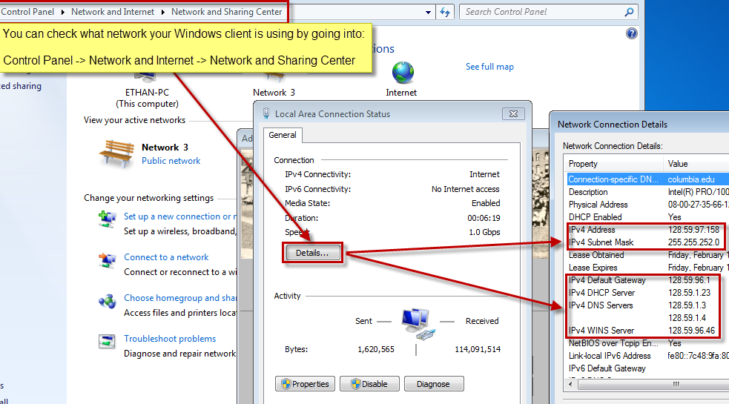

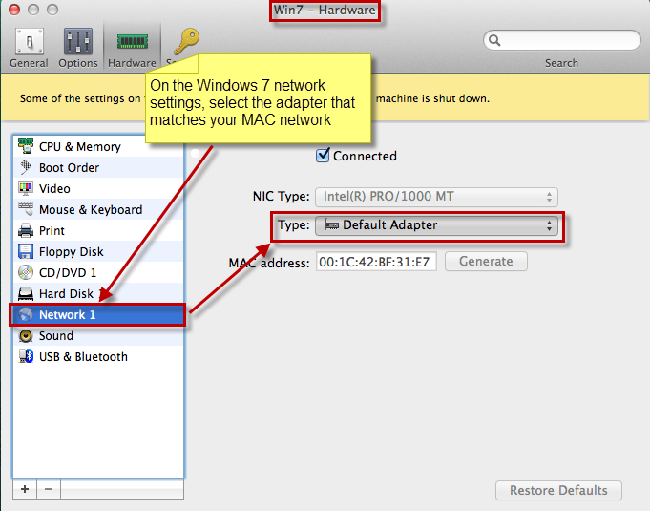

On the MAC network:

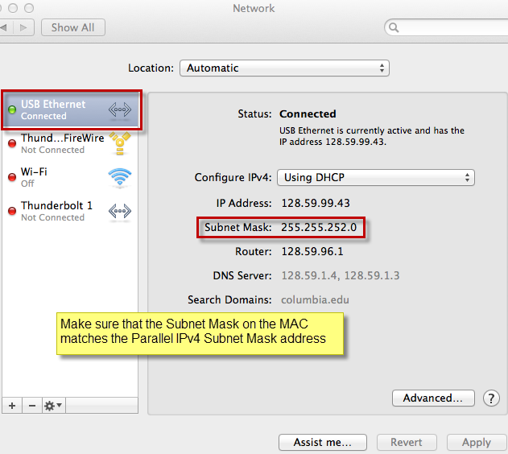

We came across an issue with Thunderbolt connection on MAC where the Ethernet connection was not being read well. What we did to solve the issue was unplug the Ethernet cable, delete the Thunder bolt connection and then plug the Ethernet cable back in. After that we “Revert” the changes leaving the Ethernet connection as the default.

**FTP Pops up briefly and then disappears and :**

This is issue might be causes by multiple Advance folders existing within the “Program Files” and “Program Files (x86)” folders. If the file exists in both folders, delete the ”Advance” folder in the “Program Files” folder. Note: This error has occurred multiple times at CUMC because of a file redirect.

Please have your IT run through the installation steps in the attached doc. Also, please make sure that an "Advance" folder only exists in the C:\Program Files (x86) folder and not in the C:\Program Files folder.

Let us know if you need anything else.

Thanks,