How to Set your Default Printer

1. Begin by opening the [Start] menu. Then click [Devices and Printers]. A list of printers should then appear.

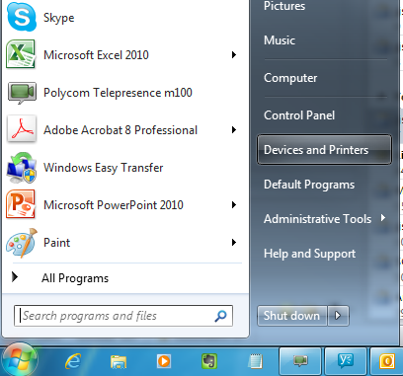 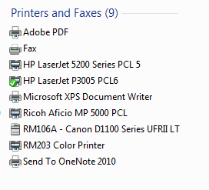

1. Right click on the printer you would like to use as your default, then click [Set as default printer]

